

Shirley Friendship Fund
2026 Application for Backpack

The Shirley Friendship Fund, a local charity for over 40 years, serves Shirley residents who are in need throughout the year, especially during the Holiday season.
Shirley residents, businesses and other charities provide our funding.
This is the 6th year the Shirley Friendship Fund will be providing backpacks
filled with school supplies for eligible Shirley school-aged children (K thru 8).
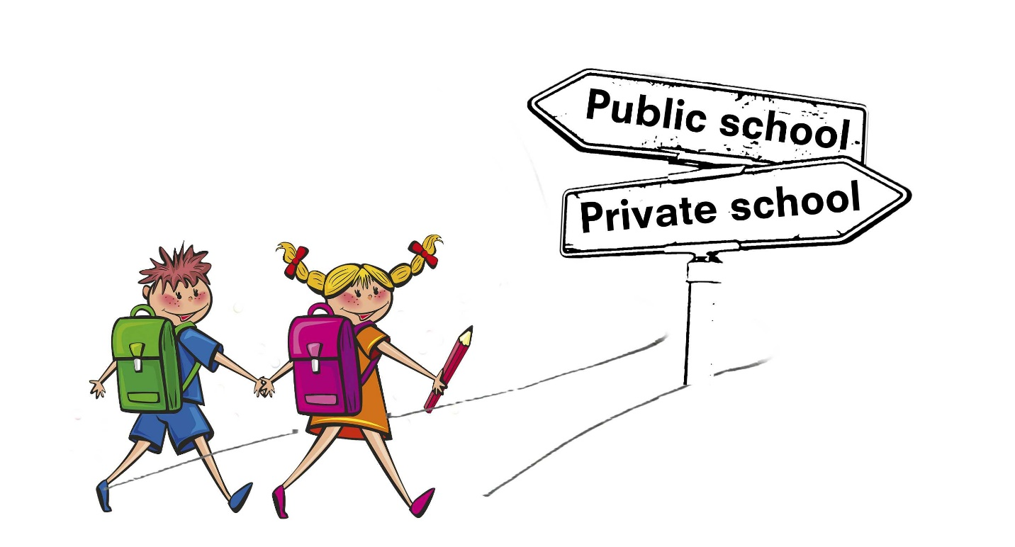

All applications are due by July 15th. Mail to Shirley Friendship Fund,
PO Box 564, Shirley, MA, 01464 OR Email to shirleyffund@yahoo.com.
Pick up will be by appointment starting Aug. 7th at the Center Town Hall.
Therefore, accurate contact information is required.

If you have any questions, please call Kellie Shakarian (978) 660-1750.

Please fill out the information below for each backpack requested.
Child’s Name:
Address:
Email Address:
Phone No.: | Favorite Colors:
Child’s Age: | Likes:
Grade Entering: | School:

